**National Textile University, Faisalabad**



**Department of Computer Science**

|  |  |
| --- | --- |
| **Name** | Abdul rehman |
| **Class** | SE-5th (A) |
| **Reg. No.** | 23-NTU-CS-1122 |
| **Course** | Operating System |
| **Submitted To** | Mr Nasir |
| **Submission Date** | 26/09/2025 |
| **Lab No.** | 2 |

# Part 1: Linux Environment Orientation

## Understanding the Linux Environment

**Concepts to Cover:**

 What is Linux? Brief history and distributions  Linux vs Windows: Key differences

 Understanding the shell (bash)

 WSL2 as a Linux environment

**Hands-on Activity:**

# Students open WSL2 terminal and explore whoami # Check current user

pwd # Print working directory

uname -a # System information

date # Current date and time

## Getting Help in Linux

**Commands to demonstrate:**

man ls

ls --help which ls type ls

# Manual pages

# Built-in help

# Location of commands

# Command type information

**Remarks**

Copies the file hello.txt to backup.txt.

# Used for creating a backup of a file.** Part 2: File System Navigation

## Understanding Linux Directory Structure

**Concepts to Cover:**

 Root directory (/)

 Important directories: /home, /usr, /etc, /var, /tmp

 Absolute vs relative paths

 Hidden files and directories

**Demonstration:**

ls /

ls -la cd /home cd ~

cd -

# Root directory contents

# Long listing with hidden files # Change directory

# Home directory shortcut

# Previous directory

## Basic Navigation Commands (15 minutes)

**Commands to practice:**

pwd

ls

ls -l ls -la ls -lh cd

cd ..

cd ~

cd /

# Present working directory

# List directory contents # Long format

# Include hidden files # Human readable sizes # Change directory

# Parent directory # Home directory

# Root directory

**Remarks**

Copies the whole directory mylab2 into mylab2_backup.

The -r option allows copying folders with their contents.

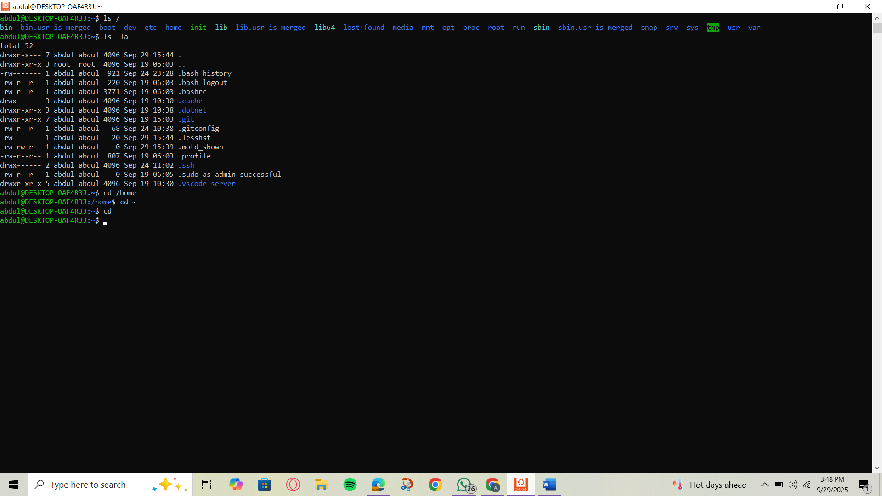

**2.2  
  
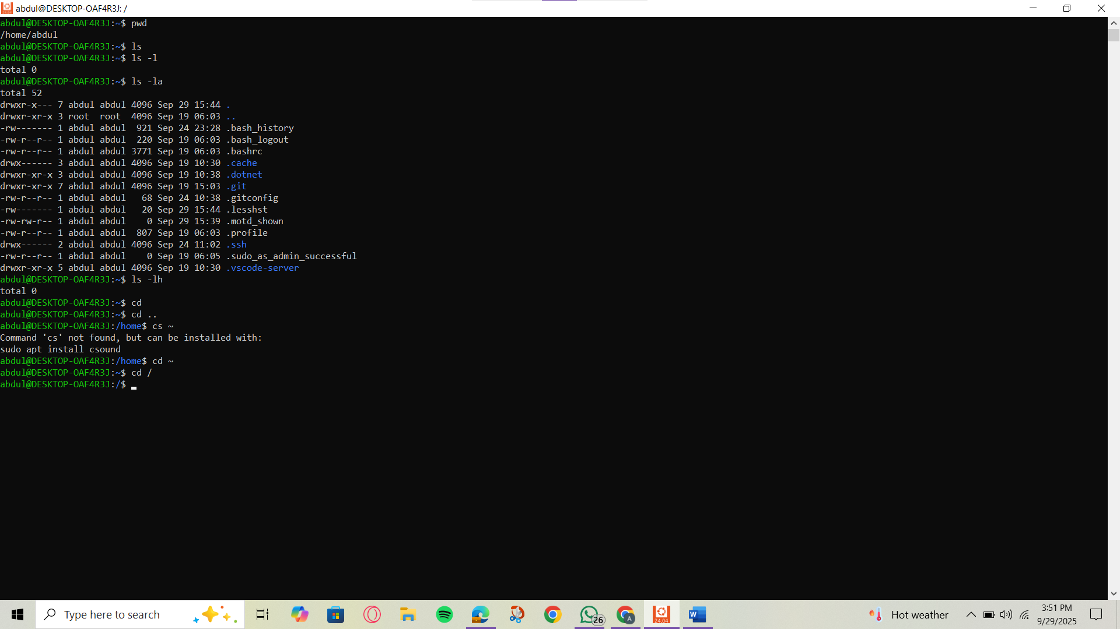**

# Part 3: File and Directory Operations

**\*\*3.1 Creating and Managing Files/Directories**

**Commands to demonstrate:**

**File viewing commands:**

cat hello.txt

less hello.txt head hello.txt

# Display file contents

# Page through file

# First 10 lines

mkdir mylab2 # Create directory

mkdir -p test/sub/dir # Create nested directories touch file1.txt # Create empty file

touch file2.txt file3.txt # Multiple files

# Text editors introduction

nano hello.txt # Simple text editor

# OR

echo "Hello Linux!" > hello.txt # Redirect output to file

tail hello.txt

wc hello.txt

# Last 10 lines

# Word count

## 3.2 Copying, Moving, and Deleting

**Commands to practice:**

cp hello.txt backup.txt # Copy file

cp -r mylab2 mylab2_backup # Copy directory recursively mv backup.txt renamed.txt # Move/rename file

rm renamed.txt # Remove file

rm -r mylab2_backup # Remove directory

rmdir empty_directory # Remove empty directory

**Hands-on Exercise:** Students create a directory structure, add files, and practice file operations.

**Remarks**

Renames backup.txt to renamed.txt.

mv can also move files between directories.

**  
  
3.2  
  
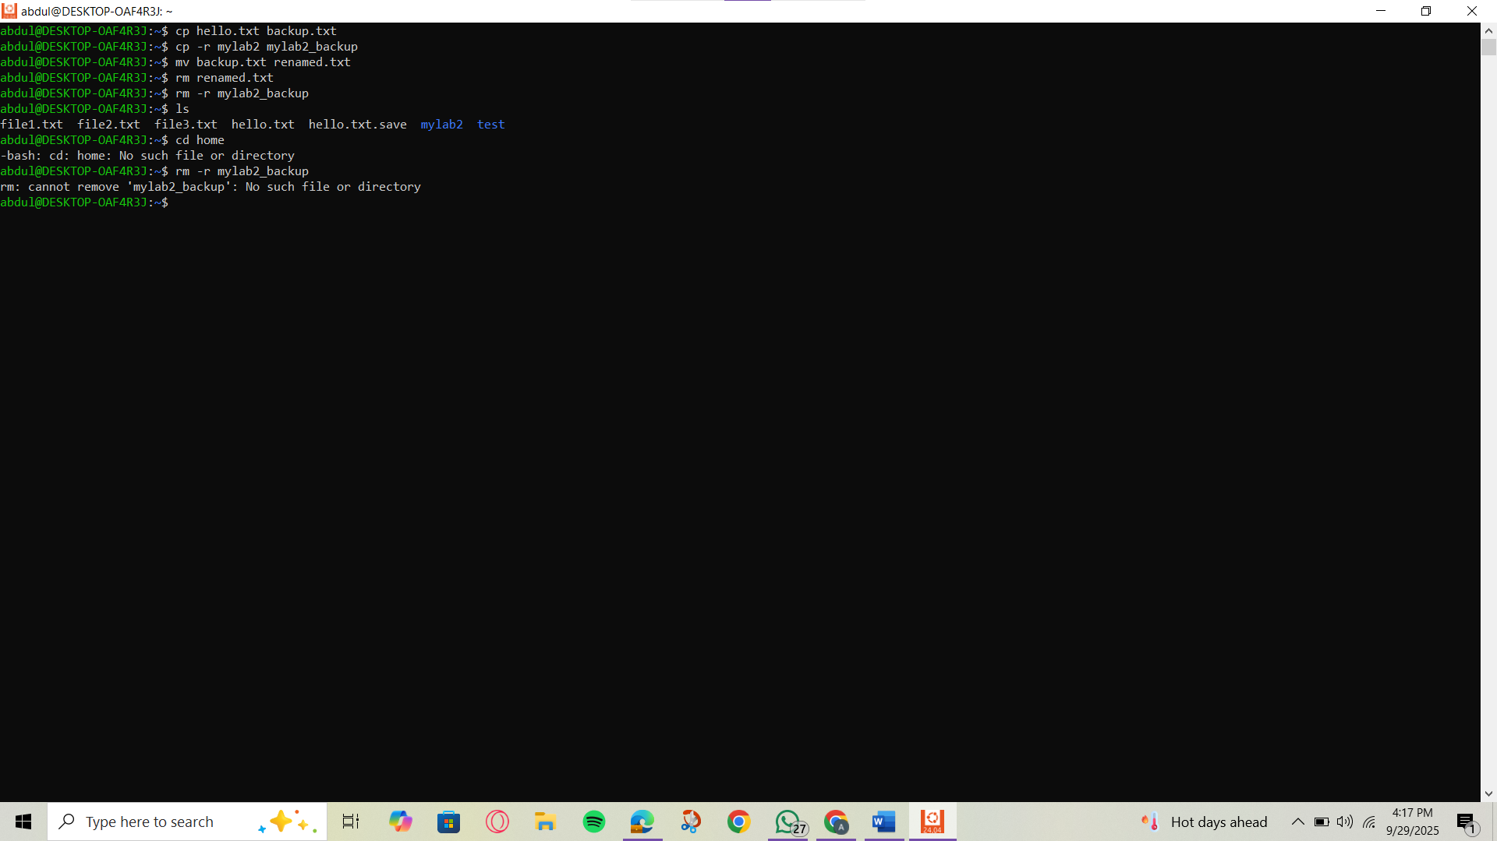**

# Part 4: File Permissions and Ownership

## Understanding File Permissions

**Concepts to Cover:**

 Permission types: read (r), write (w), execute (x)  Permission groups: user (u), group (g), others (o)  Numeric notation: 755, 644, etc.

**Commands to demonstrate:**

ls -l

chmod 755 file.txt chmod u+x file.txt

chmod g-w file.txt

# View permissions

# Change permissions (numeric)

# Add execute permission for user

# Remove write permission for group

chown user:group file.txt # Change ownership (if applicable)

**Remarks**

Deletes the file renamed.txt.

Removes it permanently from the system

